**LAB 11**

**A Taste of Data path + Control Design Example:**

**Factorial Circuit ( Open Ended Lab )**

**Objective :**

To implement a circuit that calculates factorial of a number.

**Block Diagram:**

The datapath for calculating the factorial of an “N” bit number is

given below. The datapath is controlled by a Finite State Machine (FSM). FSM

generates signals Asel, Ale, Bsel and Ble at the correct times to operate the

datapath. Input to FSM is a signal “Z” when Z=0 means the operation of the

machine is complete and ANSWER can be read. The STG is also given in the

following diagram.

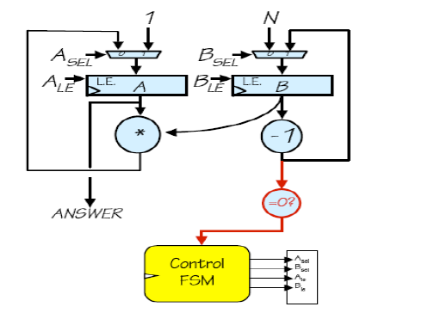

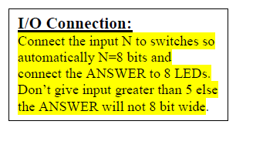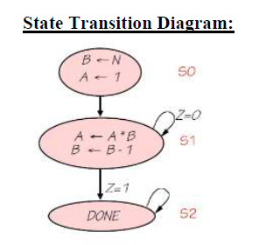

Task 2: Implement Multiplication for repeated addition using data path and control path (FSM)

Note: you can do simulation as well